Understanding microbial productivity in highly radioactive nuclear facilities
Jon Lloyd, Katherine Morris, Roy Goodacre, David Sigee and Jon Pitman
Background. The UK has a £50-£100 billion legacy of more than 60 years of nuclear fuel cycle operations. Management of sites such as Sellafield and Dounreay presents “one of the most demanding managerial, technical and environmental challenges facing the UK in the next century” (DTI, 2002). The impacts on microbial colonisation on operation and decommissioning of such sites has only recently become evident, with new molecular ecology techniques showing a surprising diversity organisms able to thrive under the highly radioactive conditions in nuclear storage facilities, using novel survival strategies (NDA Insight magazine). This initial work, based in the Manchester Geomicrobiology Group, has been developed with EPSRC DIAMOND funding through close collaborations between the University of Manchester, the National Nuclear Laboratory and Sellafield Limited. Using DNA-based analyses complex microbial communities have been characterised in a wide range of indoor and outdoor storage ponds, and here they have the potential to accumulate soluble radioactive species while impacting on plant operation and the integrity of stored materials. For example, we have shown that ponds containing LWR Fuel from the 1960s contain summer algal blooms dominated by novel radiation resistant alga related to known Haematococcus species that produce a red carotenoid pigment (astaxanthin), which may protect the cells from oxidative radiation damage. We are now moving our focus to other more radioactive environments, and the aim of this project is to build on our recent progress, and develop new “omics” techniques to give us further insight into the extent of microbial colonisation of key steps in the nuclear fuel cycle, the biochemical mechanisms that underpin survival in such inhospitable environments and the impact of microbial activity at these site.
The Project. In this project, the student will use 16S and 18S rRNA PCR-based analyses, to characterise microbial communities present in a range of nuclear facilities in the UK, focusing principally on Sellafield, generating new data on the diversity of life in some of the most extreme engineered environments on Earth. The student will also develop protocols to make maximum use of new “omics” techniques to understand the microbial ecology of these challenging and radiologically extreme environments. These will include pyrosequencing for rRNA genes in combination with metagenomic and metatranscriptomic studies (using a new Illumina MiSeq system), to investigate microbial diversity and gene expression. These studies will be augmented by a detailed set of environmental and radiochemical analyses that are collected regularly by the Sellafield staff, with additional measurements made in our laboratories in the Williamson Research Centre for Molecular Environmental Science and Research Centre for Radwaste Disposal. The student will also have the opportunity to develop metabolomic and proteomic tools for use on this project. Finally, the student will also isolate appropriate model organisms, including bacteria, fungi and algae to determine the physiological adaptations to high radiation fluxes, using EPSRC-funded facilities in Manchester’s new Dalton Cumbrian Facility. Of particular relevance will be close interactions with a new EPSRC-funded Nuclear Engineering Doctorate PhD student, and supporting staff at Sellafield Ltd and NNL developing biomass control strategies for key Sellafield ponds, and several other complementary initiatives funded by the Royal Society and RCUK/industry funding. The application of Manchester’s cutting-edge omics technologies via this project, in tandem with the parallel Nuclear Engineering Doctorate PhD project on biomass control will form the nucleus of a very powerful collaboration. Other points of contact include industry and EPSRC-funded projects on the role of biologically-produced compounds in mobilising radionuclides in Sellafield ponds, and the development of novel luminescent techniques to study microbe-radionuclide in such environments.
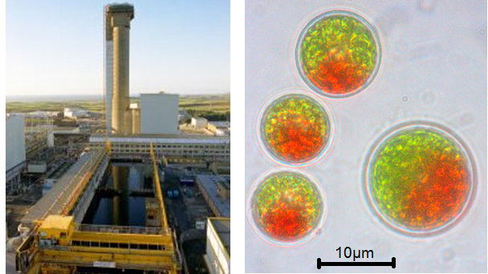
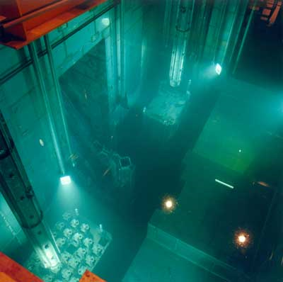
Left; Haematococcus, an algal species recently shown by the Manchester group to thrive in Sellafield nuclear fuel storage ponds.
Training.
The student will be part of the Williamson Research Centre for Molecular Environmental Science, and also the Research Centre for Radwaste Disposal in the School of Earth, Atmospheric and Environmental Sciences. The student will also spend time working in state of the art laboratories based in the Faculty of Life Sciences and Manchester’s Institute of Biotechnology, and as appropriate in nuclear regulated sites. The project will link into several ongoing EPSRC-funded projects and research networks in the area, including those noted above, and will give the student a unique training in the latest techniques from the biological and physical sciences. Students at The University of Manchester also benefit from a comprehensive program of tailored skills training as part of their postgraduate research. At the beginning of their first year, all students attend a four day Induction Course during which they are introduced to facilities available in the School and University. Further, expert led courses in research management, research in practice and scientific writing are also undertaken as part of the needs driven student personal development plan. Finally, technical support on lab procedures including microbiology, molecular biology, radiochemistry, spectroscopy, etc., is offered within the vibrant group of 40+ academic, research staff, technical staff and research students in the geomicrobiology and nuclear environmental groups in Manchester.
Further Information.
NDA Insight Magazine (2012). It’s a bug’s life at Sellafield. June 2012
DTI (2002). The Nuclear Legacy: A Strategy for Action. Cm 5552 DTI London
Morris, K and Lloyd, J.R. (2011) Understanding the UK’s radioactive legacy. Planet Earth, Spring 2011, 22-23
Lloyd, J.R. and Gadd, G.M. (2011). The geomicrobiology of radionuclides. Geomicrobiol. J. 28:5-6, 383-386
Vaughan, D.J. and Lloyd, J.R. (2012) Mineral-organic-microbe interfacial chemistry. In “Fundamentals of Geobiology” (Editors: A.H. Knoll, D.E. Canfield and K.O. Konhauser). Wiley-Blackwell, Chichester UK. Pages 131-149
Evans, V.E., Boothman, C, Morris, K., Sigee, D., Anderson, L. and Lloyd, J.R. (submitted). A thriving microbial ecosystem adapted to life in a nuclear fuel storage pond. ISME Journal.

